



2025

Northern Illinois University | 1120 East Diehl Road | Naperville, Illinois





Lunch & Snack Breaks - Provided (each day) | EARLY BIRD REGISTRATION DISCOUNT | After 7/1/2025*
Monday, 9/15/25 | $200.00 | $250.00
Tuesday, 9/16/25 | $200.00 | $250.00
Wednesday, 9/17/25 | $200.00 | $250.00
*Veterans with Military ID receive Early Bird Rate
Registration for all 3-Days | $575.00 | $700.00
Student Registration w/ID $50.00, per day

Refer to conference
Website for sessions, times and titles.

For map, directions or to register go to
www.ChiSafetyConf.org

PLEASE SHARE WITH A COLLEAGUE
ABOUT THE CONFERENCE

The Chicagoland Safety, Health & Environmental Conference is for professionals who have responsibilities related to safety, health, training, and environmental management. Other key personnel such as owners, managers, supervisors, safety committee members, human resource managers, municipalities, and others
are encouraged to attend.

Attendees will enjoy:
- Dynamic conference workshops and sessions
- Knowledgeable speakers providing current, timely and relevant information
- Basic, Intermediate and Advanced level training sessions
- Wednesday Business EXPO featuring great products and services
- Lunch provided and Free Ample Parking
The exhibit area is free to the participants

Conference is co-sponsored by:
- Chicago Local Section of AIHA
- Chicago Chapter - AHMP
- Greater Chicago Chapter - ASSP
- Northeastern Illinois Chapter - ASSP
- Three Rivers Chapter - ASSP

Travel Information:
Hotel and travel information can be found on the conference website at:

www.ChiSafetyConf.org or www.visitnaperville.com www.discoverdupage.com

Continuing Education Credits (CEU’s) Information:
Check website for requirements and information.

Speaker Information & Session Descriptions:
The description for offered workshops and sessions and presenter information is available at: www.ChiSafetyConf.org

Business EXPO Exhibitor Information for September 17, 2025:
The Exhibitor Packet is available at www.ChiSafetyConf.org. Register early for an EXPO booth!

Planned in Association with:
- Occupational Safety & Health Administration

KEYNOTE SPEAKER: Mayor Scott A. Wehrli - Mayor of Naperville

Tuesday, September 16, 2025 at 8:30am in the Auditorium

With decades of experience in business, banking, law enforcement and public service, lifelong Naperville resident Scott Wehrli was first elected to the office of mayor in 2023. A nonstop volunteer since he was 12 years old, Mayor Wehrli is keenly aware of the decisions that make Naperville one of the greatest communities in the country in which to live, work, raise family or retire. Mayor Wehrli leads the City with a focus on public safety, economic development & sound fiscal policy, supporting a thriving local economy and providing residents a safe place to call home..

For his full bio, please see our website at ww.chisafetyconf.org.

Monday, September 15, 2025

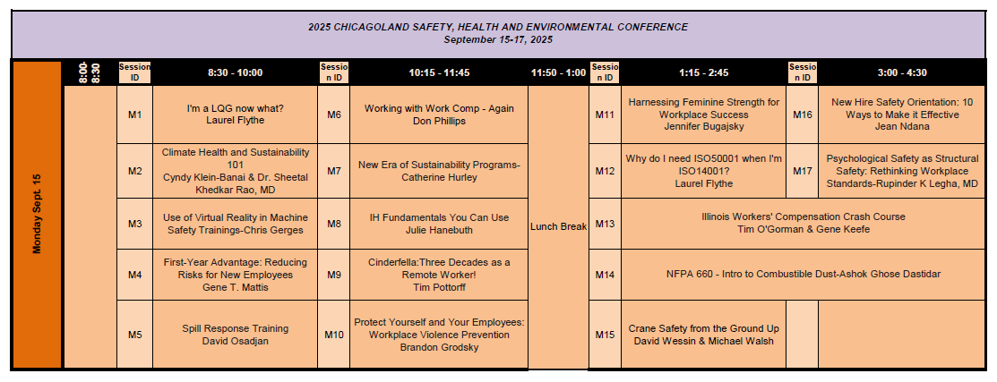

M5
M6
M7
M8
M9
M10
M11
M12
M13
M14
M15
M16
M17
Check Box for Sessions Attending
M1
M2
M3
M4

Tuesday, September 16, 2025

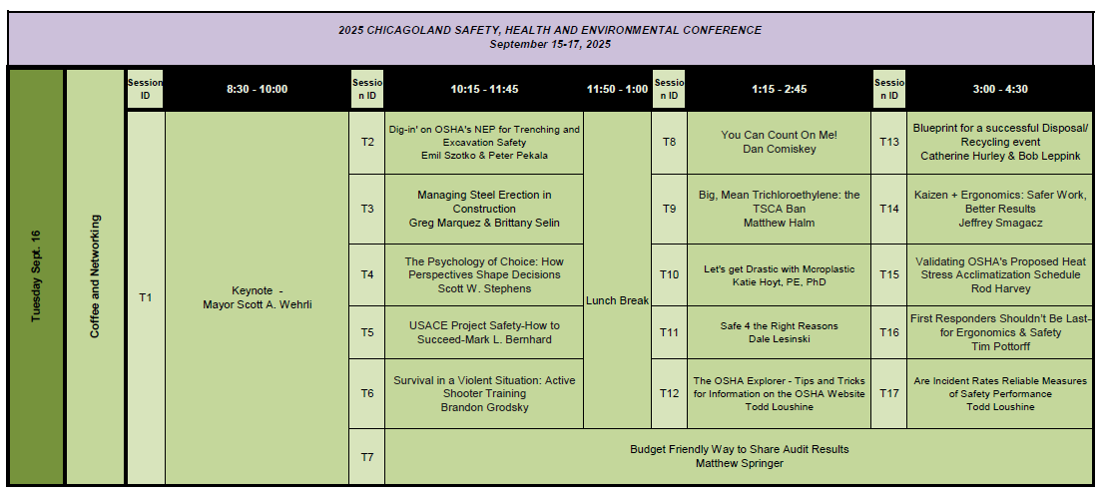

Check Box for Sessions Attending

T16
T17
T11
T12
T13
T14
T15

T6
T7
T8
T9
T10

T1
T2
T3
T4
T5

Wednesday, September 17, 2025

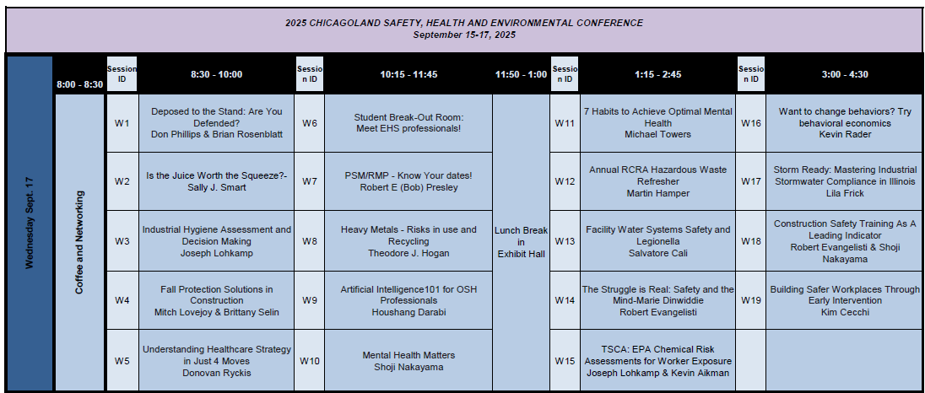

Check Box for Sessions Attending

W1
W2
W3
W4
W5
W6
W7
W8
W9
W10
W11
W12
W13
W14
W15
W16
W17
W18
W19

Note: Be sure to visit the Business EXPO today!

THANK YOU SPONSORS AND SUPPOR TERS

Chicagoland Safety, Health & Environmental Conference
Training EHS Professionals Since 1988
September 15-17, 2025
Name:
(as it should appear on your name badge)
Company: Job Title: Address: City: State: Zip: Phone: E-mail:
If applicable, check appropriate status:
I am a presenter (date):
I am a student (school): I am with OSHA
I am a Veteran (branch: ___________________)

MEMBER NUMBER:
(These below are required fields.)

ASSOCIATION: AHMP AIHA ASSP: Chicago, NEIL,
Three Rivers Chamber of Commerce Manufacturing Assn NFIB University
Other

INDUSTRY: Auto Construction Chemical Health Energy Food Government Retail-Wholesale Service Material Handling Transportation
Other

How did you hear about the CSHEC? OSHA Past Attendee Newspaper/Magazine Construction Safety Council Small Business Adm
Other

Lunch & Snack Breaks - Provided (each day) | EARLY BIRD REGISTRATION DISCOUNT | After 7/1/2025*
Monday, 9/15/25 | $200.00 | $250.00
Tuesday, 9/16/25 | $200.00 | $250.00
Wednesday, 9/17/25 | $200.00 | $250.00
*Veterans with Military ID receive Early Bird Rate
Registration for all 3-Days | $575.00 | $700.00
Student Registration w/ID $50.00, per day

Be sure to include the Session Selection form with this registration form and payment.

Refer to conference Topic Matrix for sessions, times and titles.
Payment is due with registration

Internet (Secure): www.ChiSafetyConf.org
Mail: Mail your registration forms and check payable to Northern Illinois University or credit card information to:
University Outreach Services - Registration Event #20012
Northern Illinois University
DeKalb, Illinois 60115-2854
Fax: Send your registration forms and completed credit card information to: 815-753-6900
Credit Card Type: Visa / MC DISC AMEX Expiration Date:
Card # Signature:
(Name on card if different from registration name (print):
Refunds before 7/31/2025 will be charged a $15.00 processing fee per person. No refunds will be allowed after 7/31/2025. Registration substitutions are allowed. Registration confirmations will be sent within 2 business days of registration.

American Society of Safety Professionals Northeastern Illinois Chapter
P.O. Box 59192 Schaumburg, IL 60159


September 15-17, 2025 www.ChiSafetyConf.org
PLEASE SHARE WITH A COLLEAGUE!

PROFESSIONAL TRAINING:
  - Environmental Management
  - General Safety
  - Industrial Hygiene
  - OSHA Compliance
  - Professional Development

Network and meet fellow professionals across many industries. Enjoy dynamic presenters and activities!

There is a lot to see and do in Naperville. www.visitnaperville.com www.discoverdupage.com
NIU Naperville Campus 1120 E. Diehl Road Naperville, IL 60563

For map, directions or to register go to

www.ChiSafetyConf.org


This conference and facility are handicapped accessible.

Visit the website at www.ChiSafetyConf.org frequently for the updates/overviews/directions.

